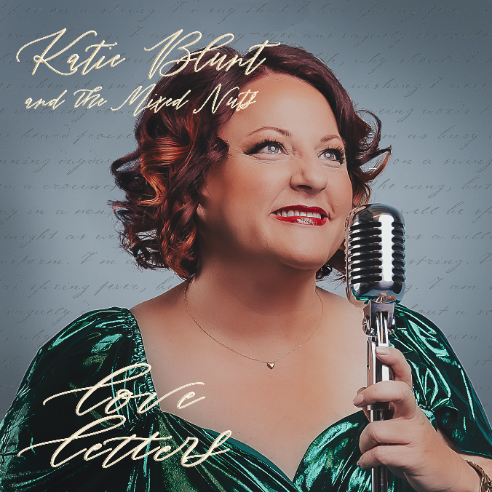
Mixed Nuts


Tonight at 7:00 p.m. Feb 27, 2025
Get ready for a journey through the golden era with our set of big band hits from yesteryear featuring Katie Blunts new album “Love Letters”.

Mixed Nuts


Tonight at 7:00 p.m. Feb 27, 2025
Get ready for a journey through the golden era with our set of big band hits from yesteryear featuring Katie Blunts new album “Love Letters”.

